Selection Process
- Complete Employment Application
- Background Investigation
- Criminal History Check
- Psychological Exam
- Fingerprinting
- Oral Review Board
- Interview with Chief of Police
- Medical Exam and Drug Screen
- Offer Letter

Academy Admission
- MCOLES Physical Fitness Test
- MCOLES Reading & Writing Exams
- MCOLES Licensing Exam

Physical Requirements
For admission into the Police Academy if not certified. Based on the Michigan Commission of Licensing Standards (MCOLES), candidates must satisfactorily pass a Physical Fitness Test
based on the following requirements:
MALE:
- Vertical Jump (15-17 inches)
- Sit-Ups (30-32)
- Push-Ups (28-30)
- 1/2-Mile Shuttle Run (4.29-4.54 min)
FEMALE:
- Vertical Jump (8-11 inches)
- Sit-Ups (18-28)
- Push-Ups (7)
- 1/2-Mile Shuttle Run (5.35-6.13 min)
To Apply
Applications may be obtained from:
or visit our website at www.cityofinkster.com


INKSTER POLICE DEPARTMENT
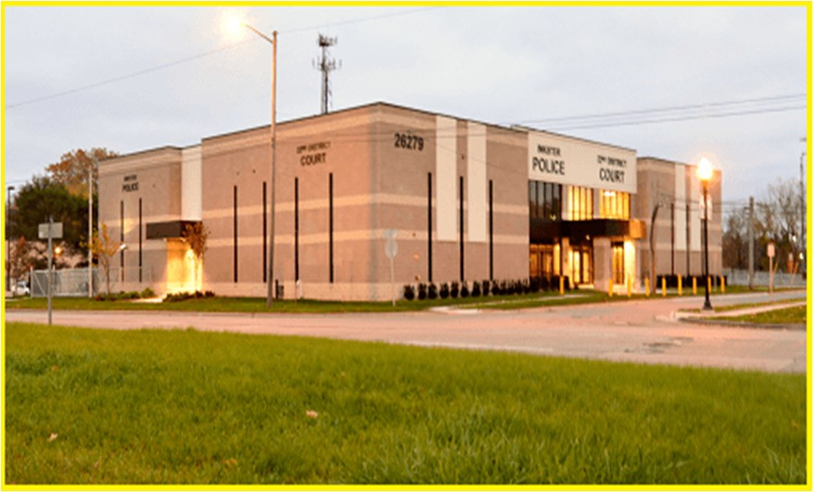
26279 Michigan Avenue
Inkster, MI 48141
(313) 563-9850

The City of Inkster is an Equal Opportunity Employer and does not discriminate based on sex, religion, age, handicap, or national origin.
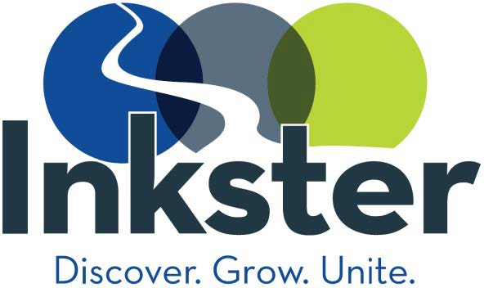
The City of Inkster Police Department

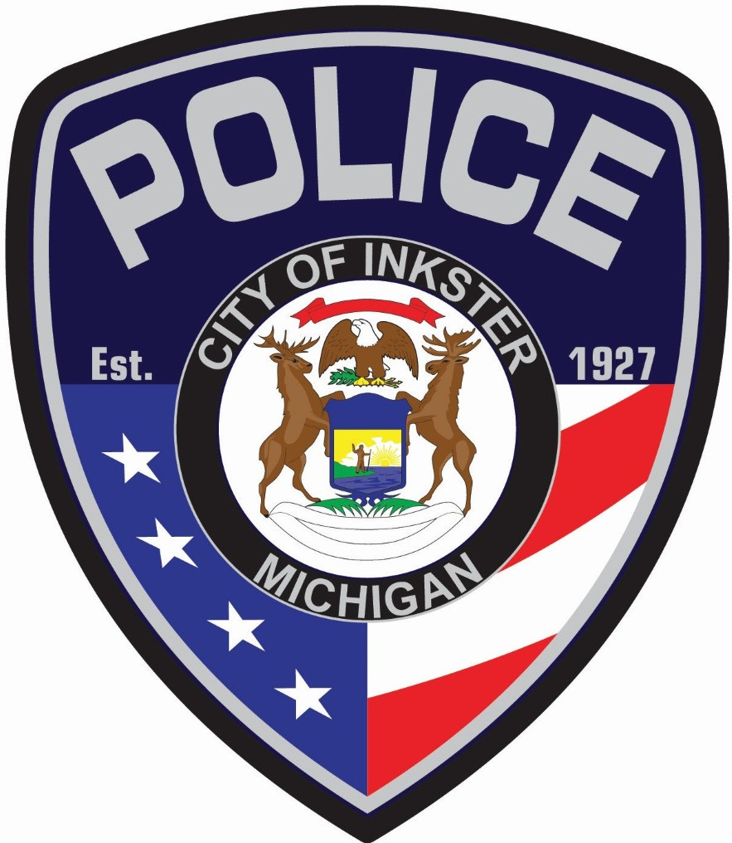
Invites your Application for


POLICE OFFICER

Benefits
- Major Medical / Dental Insurance
- Optical Insurance
- Short-Term/Long-Term Disability
- Life Insurance
- 13 Paid Holidays
- Vacation / Personal / Sick Leave
- Military Leave
- Bereavement Leave
- Pension Plan With 2.75% Multiplier
- Deferred Compensation Plan
- Annual Education Bonus
- Annual $2,500 Equipment Allowance
- Annual $2,380 Holiday Pay
- Officer Starting Salary $33,322
- Officer Salary After 4 Years $53,269
- 12-Hour Shifts
- Overtime / Court Overtime Pay
- Union Membership

Incentives
- Opportunity to promote to Detective, or Sergeant within 2 years
- Shift Differential Compensation
- Specialized Training Opportunities
Officers residing within the limits of the City of Inkster are also entitled to:
- $500 Yearly Cost of Living Stipend
- Mortgage Assistance Program
- Take Home Vehicle Policy

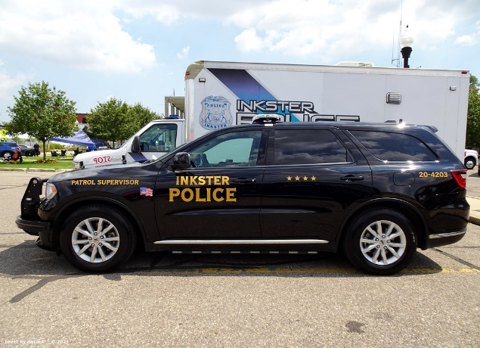

Basic Requirements
- 18 Years of Age
- United States Citizen
- High School Diploma or GED
- Possess Good Moral Character
- Valid Michigan Driver’s License
- 20/20 Corrected Vision
- Eligible to Complete Basic Training at an Approved Training Academy
(or)
- Already MCOLES Certifiable

Specialty Units
- Patrol Operations
- Investigative Unit
- Motorcycle Unit
- Community Relations Unit
- K-9 Unit (currently being implemented)
- Records Bureau
Typical Responsibilities
- Patrol and supervise the community
- Investigate crimes, crime scenes, and accidents
- Act as first responder in the event of a crisis
- Apprehend and detain offenders
- Provide emergency assistance to individuals injured in accidents or crimes
- Obtain evidence/secure interviews from witnesses at crime scenes
- Testify in court for cases involved in
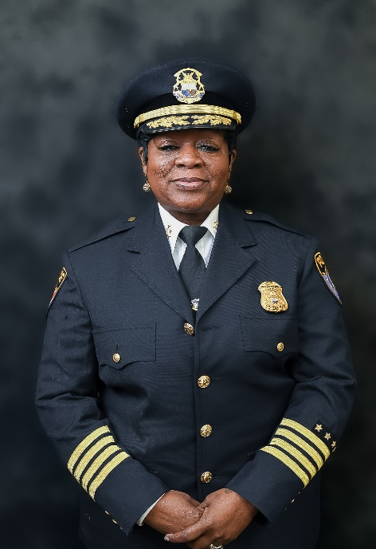
Tamika Jenkins Chief of Police

