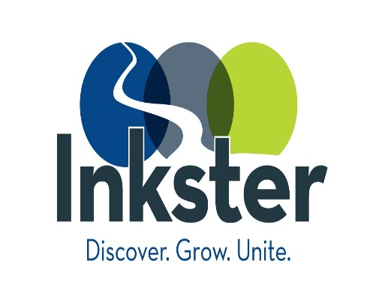
CITY OF INKSTER
TAX INCREMENT FINANCE AUTHORITY

REGULAR MEETING
Thursday, July 8, 2021
6:30PM
ZOOM

AGENDA

I. ROLL CALL

II. ADOPTION OF AGENDA

III. CALL TO THE PUBLIC (Non-Agenda Items)

IV. TREASURER’S REPORT

V. OLD BUSINESS

- Approval of June 17, 2021 Meeting Minutes

VI. NEW BUSINESS

- Election of Officers

VII. MISCELLANEOUS

VIII. ADJOURNMENT

